Math 521 HW2

Raj Mohanty

raj.mohanty@student.csulb.edu

**2 Computing**

**2.1 Problem 1**

We construct the matrices as per code snippet below.

The above code snippet is for the first pattern P1.

We plot the 3 training patterns using matplotlib’s imshow function in figure 1.1.

*Figure 1.1 : The 3 training patterns*

The new pattern Pnew is shown in figure 1.2

*Figure 1.2: New pattern*

We then flatten the 3 training pattern matrices as follows and stack them in the columms of matrix V (shown in figure 1.3).

*Code snippet for flattening matrices*

*Figure 1.3 : Flattened and combined pattern in matrix V*

We then determine the orthonomal bases of V and call it M as follows:

We calculate the projection matrix P where

We flatten the Pnew pattern as follows:

Code for the above equation is

Novelty pattern =

Code :



Finally we plot the Novetly pattern in figure 1.4

*Figure 1.4: The derived novelty pattern in the new pattern*

Here we notice that yes, the pattern shown in figure 4 was missing in the 3 training pattern.

**2.2 Problem 2**

We create matrix A as follows

We display the pattern as shown in figure 2.1.

*Figure 2.1: Pattern of matrix A*

We then go ahead and determine the SVD as follows

We plot the reconstruction of as shown in figure 2.2

*Figure 2.2: The 4 reconstrution of matrix A for rank 1,2,3 and 4 from the SVD*

We notice that from rank 2 onwards the matrix A is fully reconstructed. Hence the first 2 principal components are enough to represent the variability of the data in the columns of A.

**2.3 Problem 3**

In this exercise we use a (384x384) greyscale image of a buffalo as shown in figure 3.1.

*Figure 3.1 : The chosen image (matrix A)*

We then convert the uint8 pixel values to float64 (or double) precision and determine the SVD as follows:

Figure 3.2 shows the singular value distribution of matrix A

*Figure 3.2: Singular value distribution of A*

We then calculate the energy as follows:

We notice that we reach 95% of energy at rank k = 7 as shown in figure 3.3

*Figure 3.3: Level of energy at different rank k values*

The relative error is calculated as follows



Finally we show the rank-10, rank-50, rank-100 and rank-200 approximation of image A in figure 3.4.

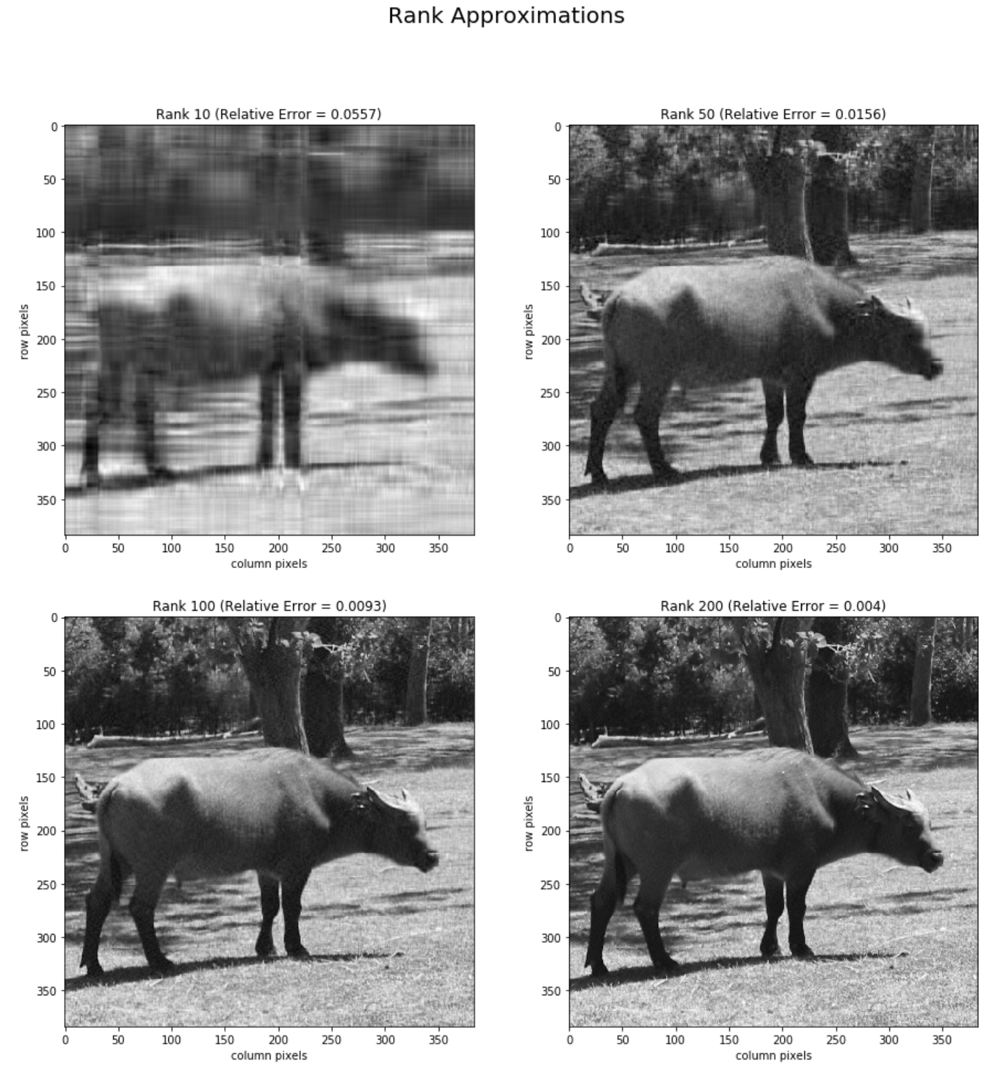

*Figure 3.4 : Various rank approximation of the original image*

We notice that we almost reconstruct the original image from at rank-50.